THREADS OF LIFE
A Registered Charity that SUPPORTS families living with the aftermath of workplace fatality, life altering injury or occupational disease.

Contributed by Heather Bouley
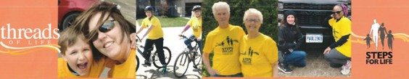

With the support of CopeLocal 96 and 4 other local unions we raised $7,100.00.

Heather Bouley, a Dietary Assistant at Thunder Bay Regional Health Sciences Centre says NO to workplace injuries and YES to Health and Safety.
Steps for Life is a walk put on to support families who have been affected by workplace tragedy. When Heather heard this event had not taken place since 2011 in Thunder Bay, she decided she had to do something. Heather worked to bring the walk back to raise awareness and funds for this important initiative.
“Together we are achieving Threads of Life’s mission: To help families heal through a community of support to promote the elimination of life-altering workplace injuries, illnesses and deaths.”
Threads of Life is a Canadian Registered Charity that provides support to families who are living with the aftermath of a workplace fatality, life-altering injury, or occupational disease. This program provides free access to peer support and links to community resources. Currently, Threads of Life are supporting over 2,900 families across Canada. Threads of Life’s mission is to “help families heal through a community of support to promote the elimination of life-altering workplace injuries, illnesses, and deaths.”
Heather was thrilled to report that “With the support of Cope Local 96 and 4 other local unions, we raised $7,100.”
Heather says she was called to this purpose when she got the call that her son had been injured in a workplace accident. He, gratefully, was okay and has since fully recovered. She recognizes that a lot of families are not as fortunate.

